**Website Description**:

**project idea (problem definition)**

Many pet owners encounter challenges not only in acquiring supplies for their beloved dogs, cats, and birds but also when attempting to buy or sell other animals. These challenges encompass:

* **Limited Local Availability:** Pet owners living in specific geographical regions may struggle to access a wide variety of pet products, resulting in a constrained choice and potentially elevated prices.
* **Supply Chain Disruptions:** Unanticipated interruptions in the supply chain, stemming from factors like natural disasters or unforeseen circumstances, often result in shortages and delays in acquiring essential pet supplies.
* **Inefficient Shopping Experience:** The process of identifying the best deals and products for their pets can be time-consuming and frustrating for pet owners, as they often need to visit numerous physical stores or navigate through various online retailers.
* **Animal Transactions:** Some pet owners find themselves in challenging situations where they need to find suitable buyers for their pet animals or locate animals for sale. However, these transactions can be problematic, making it challenging to connect with interested parties in the pet trade.

**Recommended solution**

In order to solve this problem after a long research and analysis of the requirements of the customers, we knew that the right solution was to set up a site to sell the supplies of millennials and pet.

**benefits of the provided solution:**

The fidelity of the solution is to help connect who wants to buy animal supplies but doesn't know where to go. It also provides customers who want to buy animals in it to see them on site

Storyboard for all website pages:

رسم توضيحي 1home page

SHOP ZOO

About us

Search in our store

رسم توضيحي 2homepage

Image 150 * 150

Image 150 * 150

Image 150 * 150

Dogs Cats Birds



Link1

Link2

Link1

Link2



Image product 6

Image product 5

Image product 4

رسم توضيحي 3buy dogs





image product 3

Image product 2

Image product 1

text

Bottom to return home.

text

text

text

رسم توضيحي 4 buy dog supply



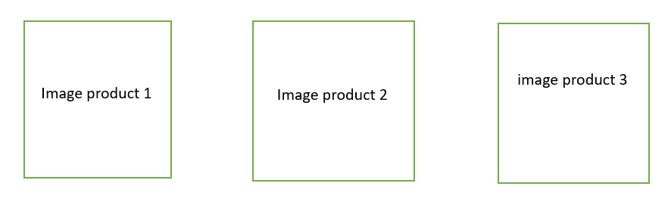









رسم توضيحي 5buy cat





رسم توضيحي 6buy cat supply



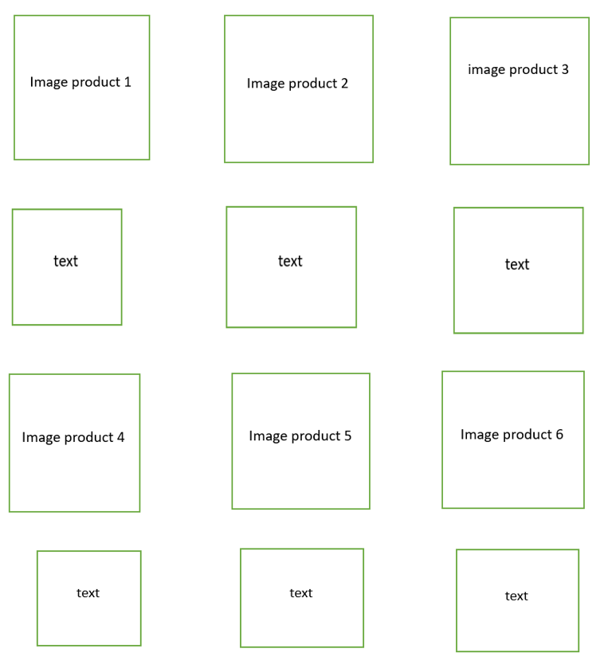





رسم توضيحي 7 buy birds

رسم توضيحي 8buy birds supply





**Site map:**

رسم توضيحي 9about us page

Text P

Header h1

